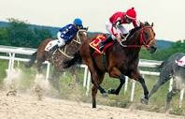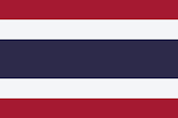
NEWTON ABBOT SQUASH & TENNIS CLUB PARTY NIGHT!
SATURDAY 26TH FEBRUARY 2022 – OLD RYDON INN BARN
MEET 7PM
RACE NIGHT (4 HORSE RACES) 730 UNTIL 830. THERE WILL BE AN AUCTION FOR EVERY HORSE IN EACH RACE SO CHANCE TO WIN SOME FAIRLY BIG MONEY, AND ALSO A TOTE ON EACH RACE FOR SMALLER BETS.
THAI BANQUET (AND VEGI OPTION) 830 UNTIL 930 – PLEASE LET ME KNOW IF ANY SPECIAL DIETARY REQUIREMENTS.
LIVE MUSIC (ROCKAFELLAS) 930 UNTIL 11PM
COST PER PERSON - £25 – PARTNERS AND GUESTS WELCOME- PAYMENT IS NON-REFUNDABLE (unless the event is cancelled)
NAMES AND PAYMENT REQUIRED BY 12TH FEBRUARY 2022 -ANY QUERIES PLEASE SPEAK TO NICK WALES OR MESSAGE ON 07958 378984.
PLEASE MAKE PAYMENT TO N WALES SORT CODE 090129 ACC NO. 18984154. PLEASE MESSAGE ONCE PAYMENT MADE.

