**Racketfans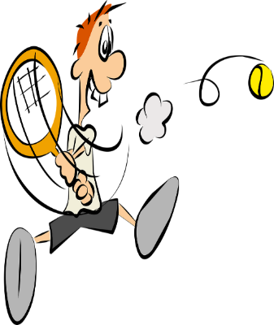December 16th**

**Hi Racketeers & Rectrusteers**

**Gringo wishing you all a merry Christmas and a very Happy New Year.**

**Thanks and congratulations to you all for keeping the racketsports active and enjoyable throughout the year. It’s been tough but you were all up the challenge and we’ve had some really great sessions throughout the year.**

**The courts and Rec Trust will be closed on Christmas Day, Boxing Day and New Year’s Day but open throughout for the rest of the time. Be sure to check out and book courts on-line first.**

**You will find details of the Sportman’s Bar openings and events on Facebook.**

**Please keep active and contact your friends to arrange as many matches/practices as you can.**

**Coaching is available for both squash/racketball and tennis.**

**The committee (Andy) is working with the LTA to plan out future developments for the tennis section. More details will be available asap.**

**The fridge in the pavilion is broken but is due to be replaced very soon.**

**Help is still needed with occasional leaf clearance (brooms etc in the pavilion).**

**If you need any help in organising matches or finding opponents contact Andy Lloyd, Glyn Davies or Granville Thomas (details available through web site).**

**Squash maintenance currently underway. Means a bit of dust but won’t stop you playing.**

**Keep Safe. Enjoy Christmas as best you can, hang tough and see you all on court very soon.**

**Gringo.**

**.**