**Racketfans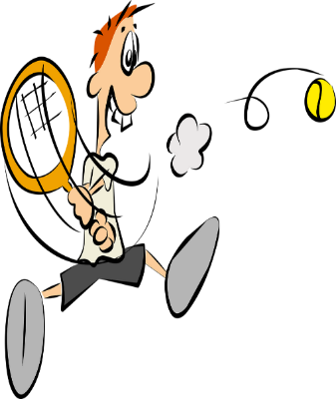November 16th**

**Hi Racketeers & Rectrusteers**

**Locked down Gringo calling…….**

**Not long now, racketeers, before we can get back to some court action.**

**Hopefully you are keeping yourself razor sharp and ready to resume the fun as soon as Boris allows.**

**I’m sure the committee will let us know how and when we can get back on court.**

**In the meantime, some news for you:**

* **The squash courts are scheduled for re-painting in December so they will be ready for us when the time comes.**
* **The heaters in the squash courts have been repaired.**
* **The committee are continuing to create a long-term strategy and development plan to ensure our great club continues long into a brighter future.**
* **Andy L is in the process of annual registration with the LTA.**
* **We have been approached by a local primary school with regards to coaching.**

**Also……have you tried resistance bands?? Brilliant. Cheap. Convenient. Very adaptable.**

**And the running????????**

**Still going. Not so ploddy.**

**See you on court soon.**

**Best wishes,**

**Gringo**