**Racketfans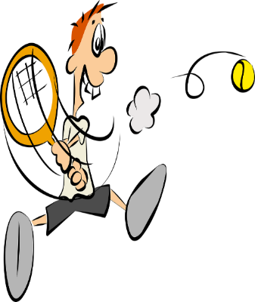November 4th**

**Hi Racketeers & Rectrusteers**

**Gringo calling…….**

**I’m sure you have all read the latest committee communicate. Sadly, no tennis, squash or racketball until December 2nd. If there is any change in the meantime, we’ll very quickly set up some racketsport opportunities for us all.**

**It also means that the Recreational Trust building and Sportsman’s Bar will be closed.**

**Thanks for all your support following the first lockdown to really get things going again and you made it a very successful and enjoyable summer of sport. We will get there again.**

**Many thanks also to Nikki and her team in the Sportsman’s for providing half -term packed lunches for local school children and thanks to those members whose donations aided the scheme.**

**Curtis has been providing some excellent squash coaching and will be available post lockdown 2 to keep up the good work. And Maddie at tennis has brought a whole new vibrancy to tennis and will be available again soon to keep up the good stuff.**

**Until we Can all get back on court again keep yourselves fit and active, take up running or cycling or skipping or anything to keep you ready for the courts again. Me??I’m going to start running again for the first time in many, many years.**

**Times are hard but we are built tough!!!!!!**

**Best wishes,**

**Gringo.**