RACKETFANS
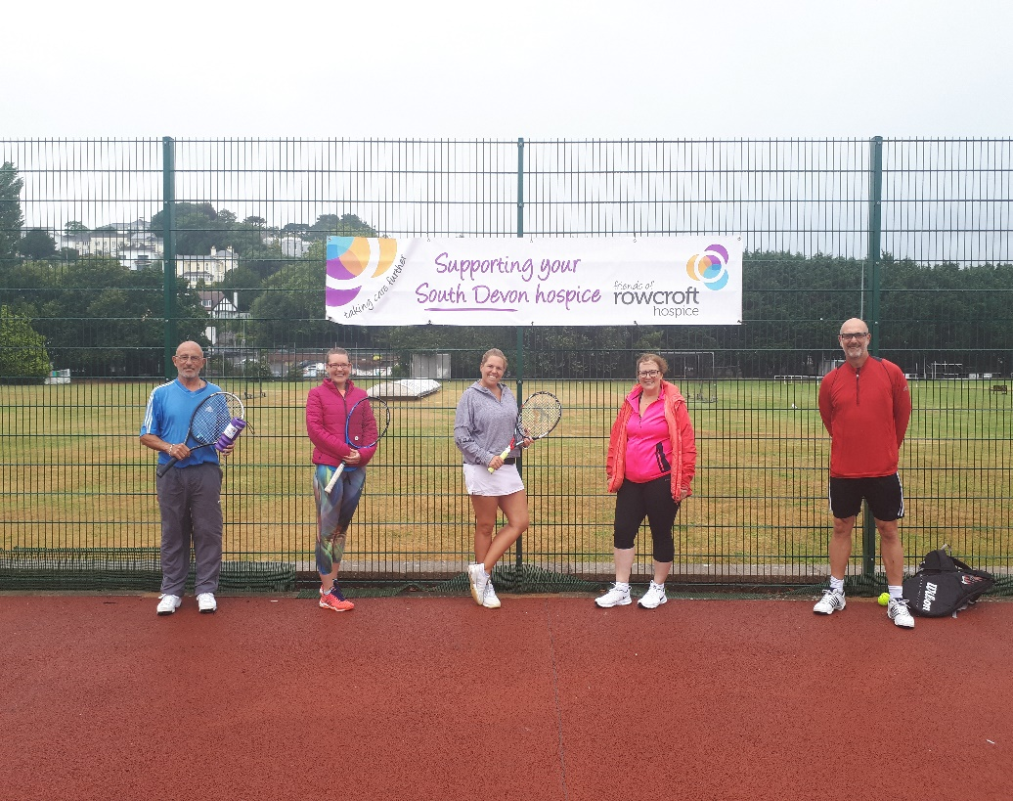

NEWS -NEWS-NEWS
Hi racketsportplayers, news from your club.
We hope you and your family are keeping well and following all social distancing objectives.
A great deal has happened at your club in recent weeks. We want you back enjoying your tennis, racketball and squash – and a drink or a snack at The Sportman’s Bar.
Please read on for some really useful information.

The Recreational Trust is now open. The toilets are open, subject to strict social distancing rules and a signposted one-way system is now in operation. The changing rooms and showers, regrettably, remain closed until further government notice.

The Sportman’s Bar is now open as follows:
Monday:Closed
Tuesday:5pm -9pm
Wednesday:5pm – 9pm
Thursday:5pm -9pm
Friday:4pm – 9pm
Saturday:12pm -9pm
Sunday:12pm – 6pm
Tables must be booked in advance (tele 01626 365343)or via Facebook. There are lots of outside tables to enjoy a refreshing drink or a freshly filled roll whilst soaking up the sun and maybe watching some cricket. Tables are also available inside for those who may wish to view the big screen TV. All drinks etc are delivered to your table and you pay (preferred method) by contactless card. Come and join us again. It’s brilliant. A strict one-way system is in operation.

Squash/Racketball.
Hooray!!!!! The courts are now available for your use. You must book on-line in advance, (the courts are open from 12pm -8pm) and follow all safety rules but come along and get back to your favourite sport. Your booking fee is also the lights charge. You’ll feel so much better for it. If you have some useful or clever tips for play under the new restrictions, why not share them here? Curtis Corby also has some cunning ideas.

Tennis
All four courts are available for on-line booking (essential). You must enter via the Cricketfield Road car park gate. Last one off court each time please remember to re-padlock. Hand sanitiser is widely available on all courts and please conform to sensible social distancing.
Club afternoons have now restarted on Saturdays starting at 1pm.
The pavilion has been thoroughly cleaned and is available for your use. But, crockery and cutlery are no longer stored there. If you require some, then bring it with you and take it away at the end of your stay. The fridge is still up and running but don’t leave food and/or drink in there for any length of time.
On Saturday 25th July a successful tournament organised by Andy Lloyd and new coach, Maddie Ramsay, raised £150 for Rowcroft Hospice. Big thanks to all of you who were involved.
And on Wednesday 28th our ladies team hosted an admirable evening match against Bovey Tracey
New coach, Maddie, will take up her roll from August 3rd and can be contacted for lessons etc via her email mad4tennisdevon@gmail.co
Junior summer activity sessions begin on Monday 3rd August. Ideal for your children/grandchildren. Contact Maddie asap for more details.
Pictured here Victor Agbaka and Mark Ayliffe battling it out for men’s’ singles champions.
Lots of opportunities to play and develop your tennis are available. Contact Andy Lloyd for more details.
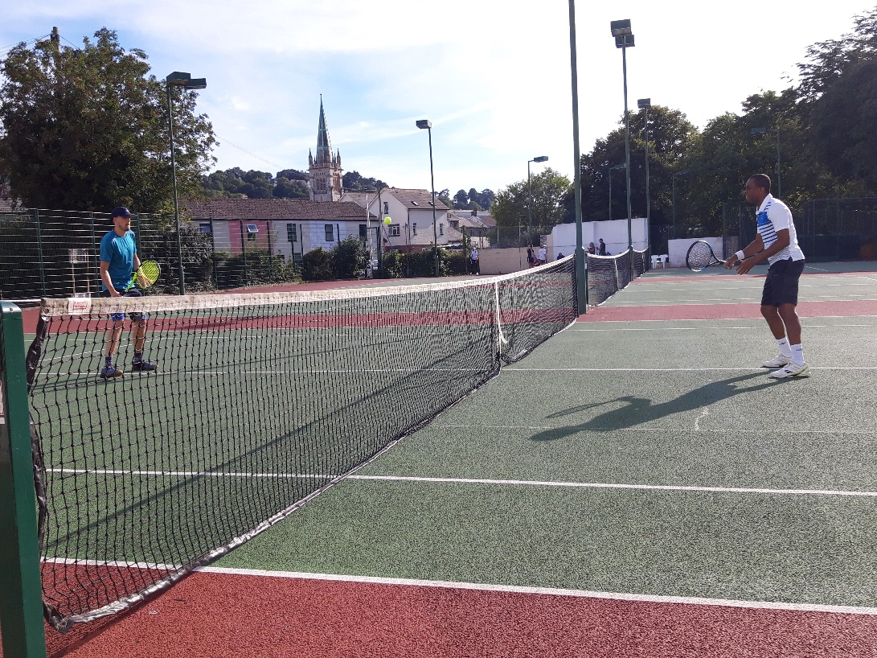
Racketfans –
We want you back. It’s not the same without you.
Best wishes from Gringo Wilson at The Rec.

