**Newton Abbot Tennis Club**

**Gordon Mellor Tournament**

**2018**

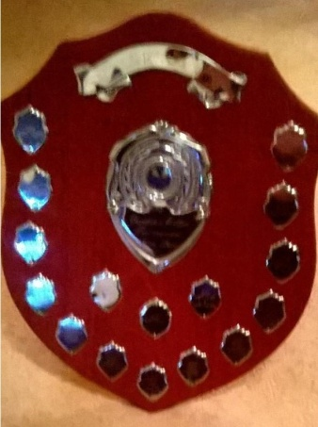**Sunday 15 April**

**1pm start**

**£3.00 entry**

**Please bring a contribution to the post-match refreshments**

**Sign-up in the Clubhouse**